***Documentation of Weekly Assignment 4***

*Question_1.py*

*Figure:*

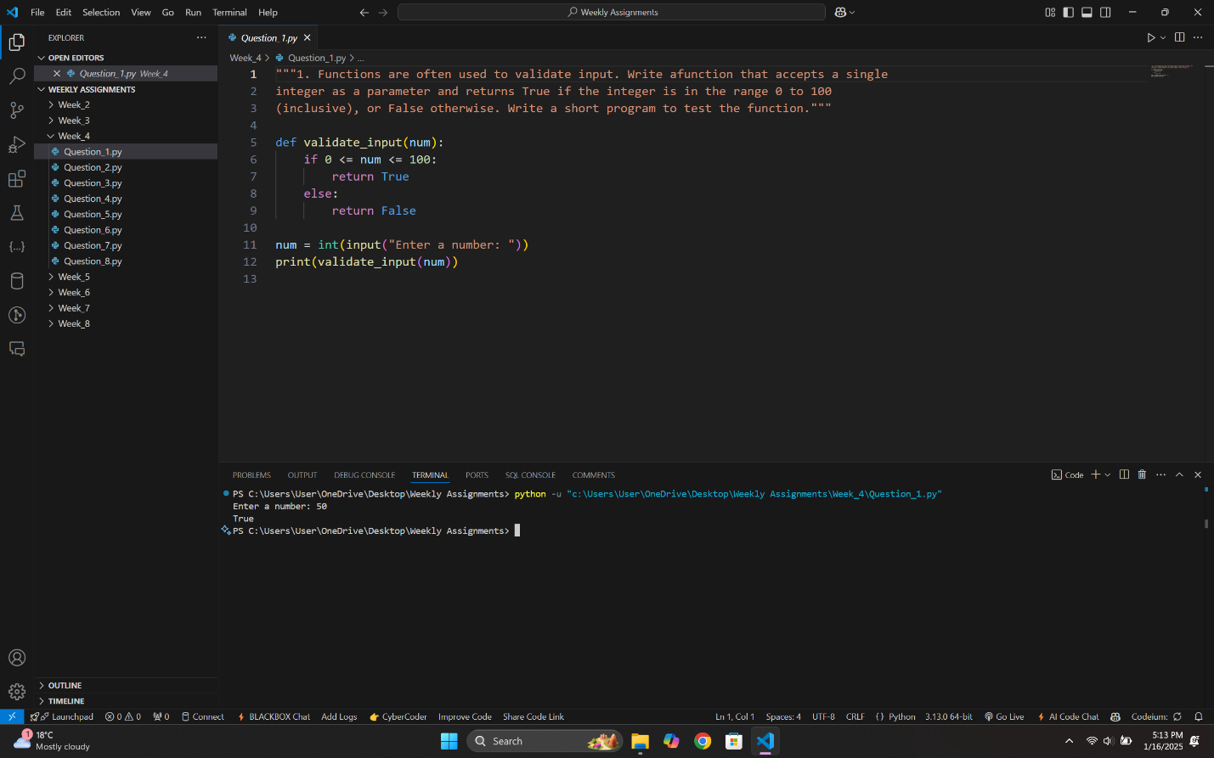

*Question_2.py*

*Figure:*

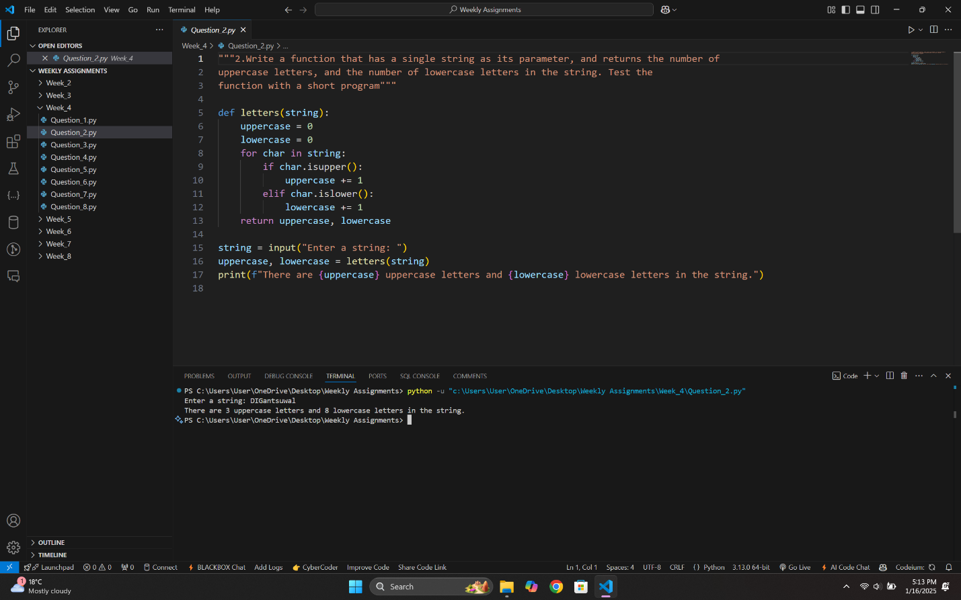

*Question_3.py*

*Figure:*

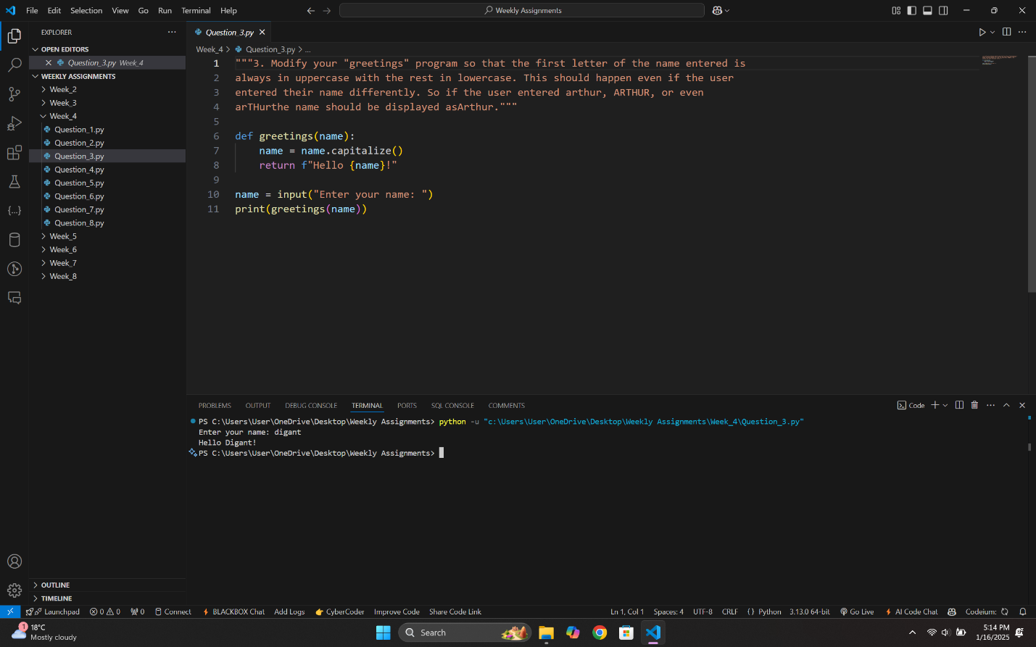

*Question_4.py*

*Figure:*

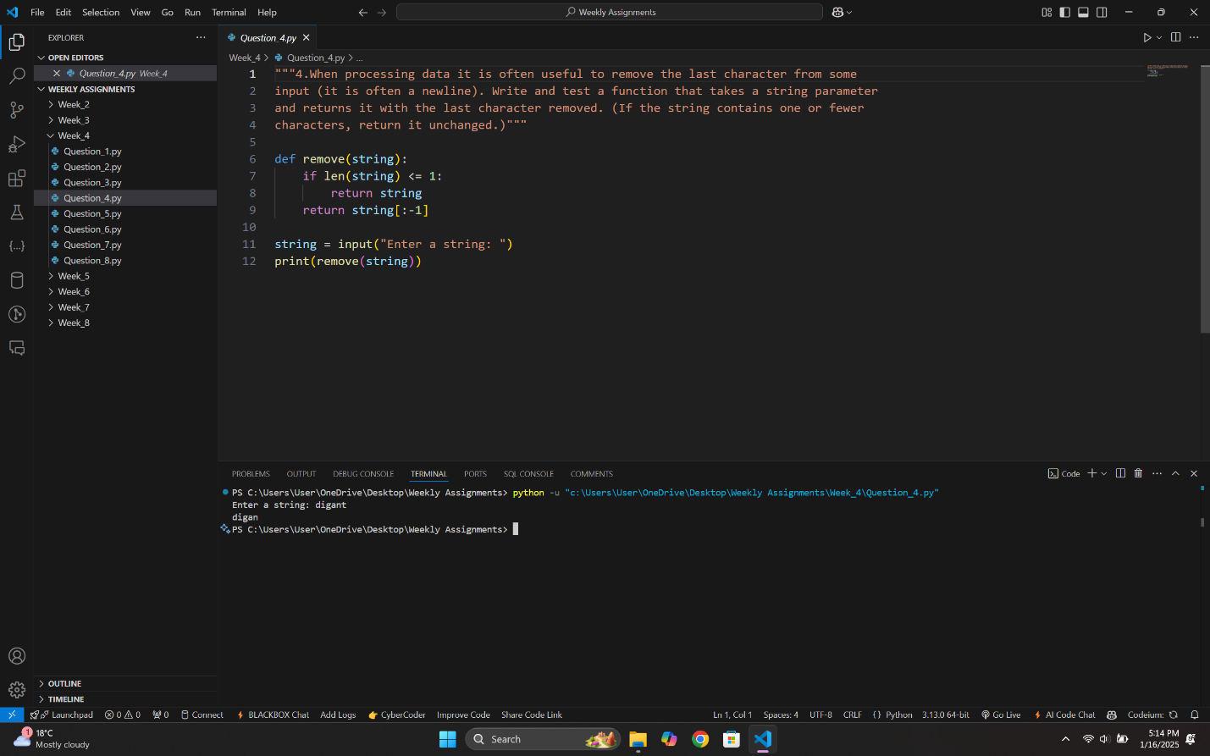

*Question_5.py*

*Figure:*

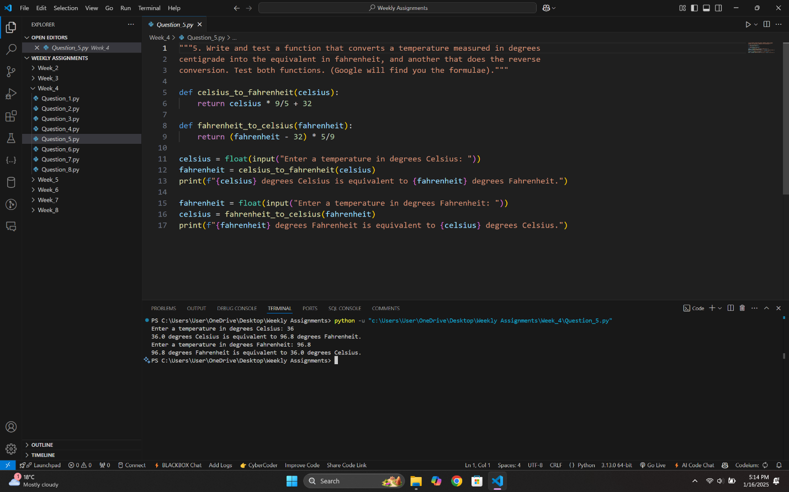

*Question_6.py*

*Figure:*

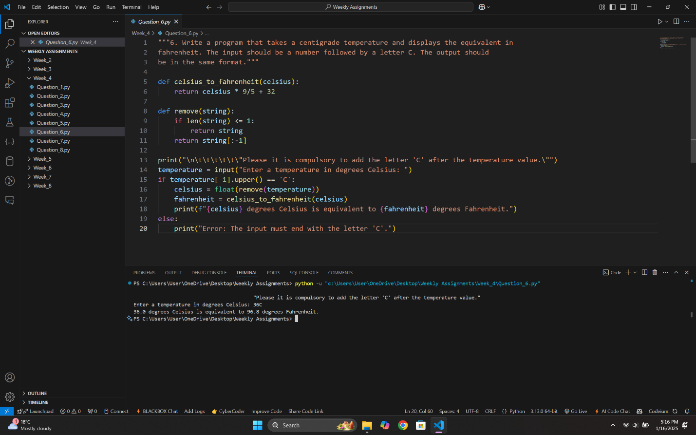

*Question_7.py*

*Figure:*

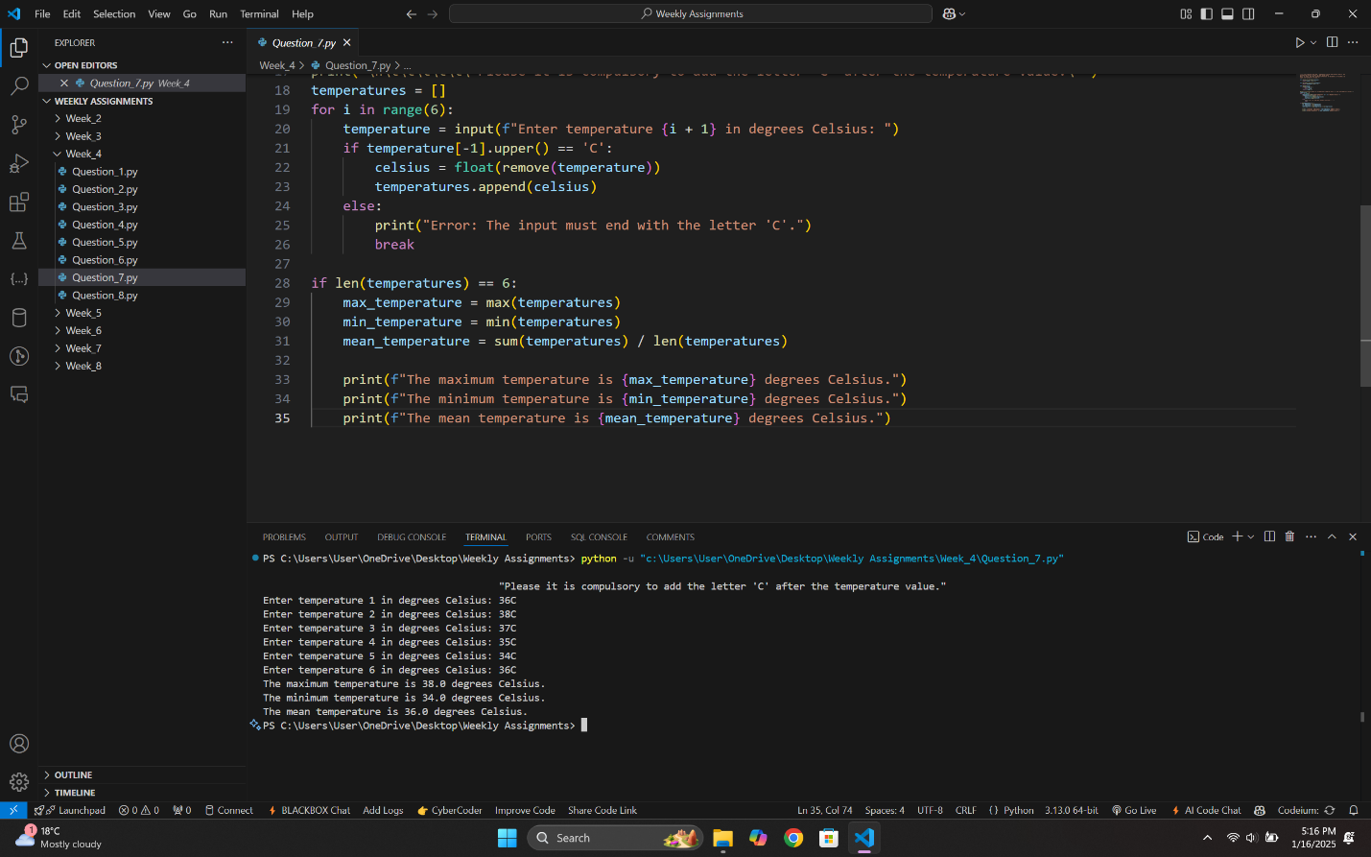

*Question_8.py*

*Figure:*

